Melanie Lorraine Salas

Research Methods Tutorial Final

May 9th 2025

For this tutorial, I will be showing you how I was able to discover the disruption of Heat Stressed being induced in pathways in such genes as LCA5L, MYBL1, and MAGEB4 while using Multi-Omics Data, R, and some ChatGPT for information that was not found. Within this research, I wanted to investigate the following key points: “How will heat stress affect gene expression associated with gene expression? How are chromatin structures adjusted in response to heat stress? Under heat stress, what is the role of protein aggregation and oxidative stress, and how does the loss of the key genes (LCA5L, MYBL1, and MAGEB4 amplify these effects? The reason for this study is that investigating these key factors will help us identify the goal of what molecular disruptions are occurring, as well as the regulation of mechanisms of germ cell survival and fertility preservation strategies. To analyze transcriptomics and the changes in chromatin under heat stress. RNA-seq and ATAC-Seq data from testicular tissue of Wild type and knockout mice, specifically LCA5L, MYBL1, MAGEB4 is going to be processed in R. All of this data will be made up from Chat gpt due to some results that I have from the genes is not fully processed and cannot be used in R. The differential gene expression will be assessed using DESeq2, which is an R package that is used to analyze RNA-seq data to identify the different genes being expressed. So, while chromatin is accessible, it will be analyzed in DESeq2, as it is being performed to analyze genomic data and even give us a visualization of what is happening in the impacts of heat stress on germ cell health, while additional statistical analyses will assess oxidative stress and protein aggregation in heat-stressed knockout mice.

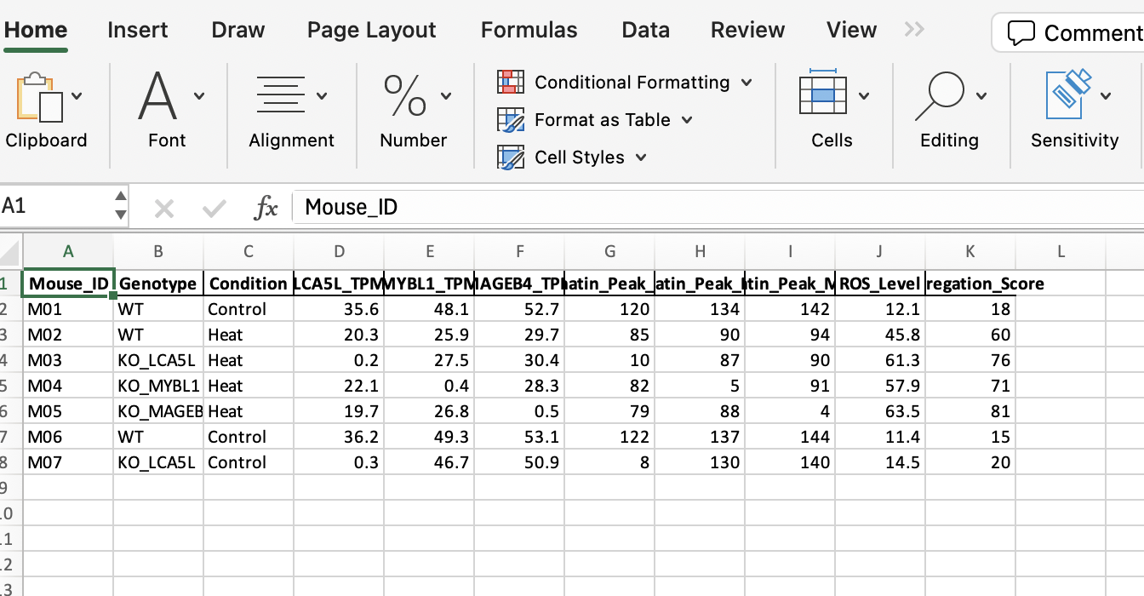  
Data Generated from ChatGpt

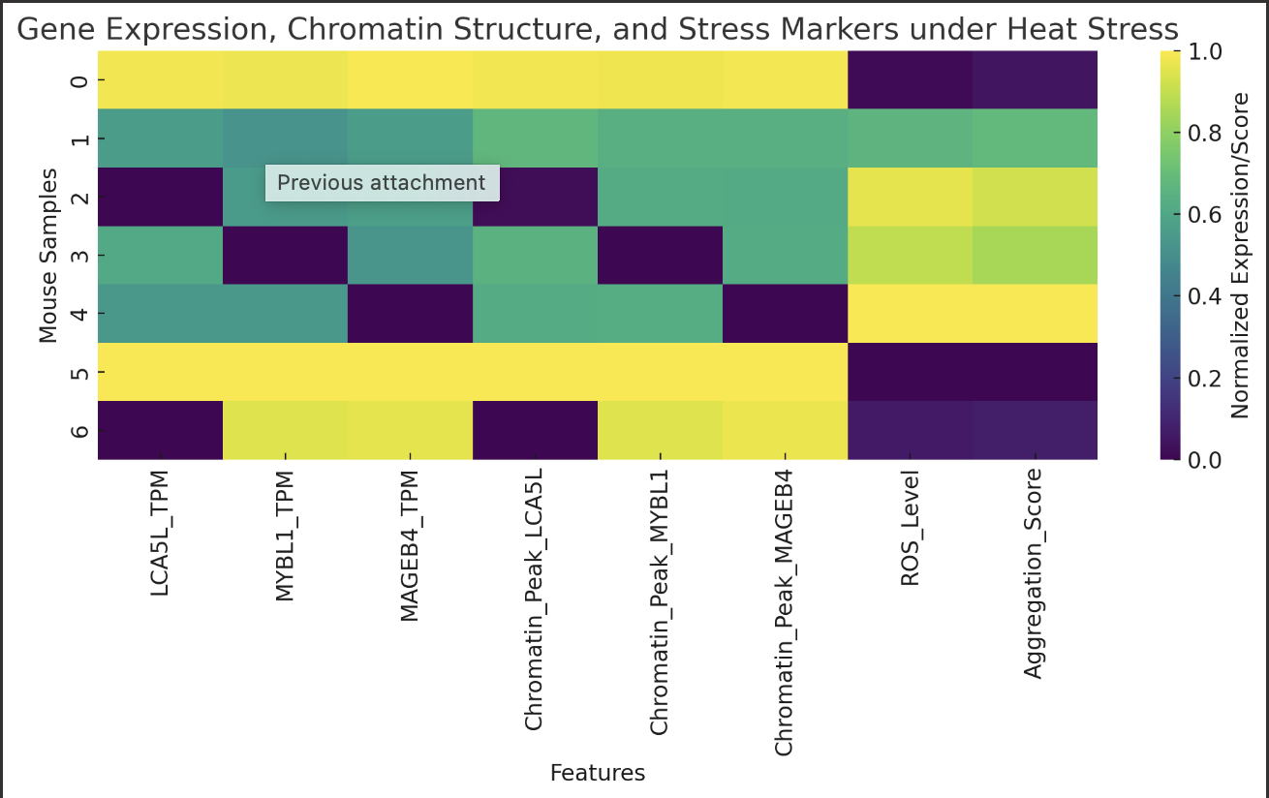

Graph that was Generated

install.packages("readxl")

install.packages("pheatmap")

# Load necessary libraries

library(readxl)

library(pheatmap)

# Load the data

data <- read_excel("Heat_Stress_Spermatogenesis_Data.xlsx")

# Select relevant columns for heatmap

heatmap_data <- data[, c("LCA5L_TPM", "MYBL1_TPM", "MAGEB4_TPM",

"Chromatin_Peak_LCA5L", "Chromatin_Peak_MYBL1", "Chromatin_Peak_MAGEB4",

"ROS_Level", "Aggregation_Score")]

# Normalize data (min-max scaling)

normalize <- function(x) {(x - min(x)) / (max(x) - min(x))}

normalized_data <- as.data.frame(lapply(heatmap_data, normalize))

# Set row names to Mouse_ID or Genotype for easier interpretation

rownames(normalized_data) <- paste(data$Mouse_ID, data$Genotype, data$Condition, sep = "_")

# Create the heatmap

pheatmap(normalized_data,

cluster_rows = TRUE,

cluster_cols = TRUE,

color = colorRampPalette(c("navy", "white", "firebrick3"))(50),

main = "Heatmap: Gene Expression, Chromatin State, and Stress Markers")

Code Ran

References

Love, M. I., Huber, W., & Anders, S. (2014, December 5). *Moderated estimation of fold change and dispersion for RNA-seq data with DESEQ2 - Genome Biology*. BioMed Central. <https://genomebiology.biomedcentral.com/articles/10.1186/s13059-014-0550-8>

QY;, Y. G. L. Y. (n.d.). *Clusterprofiler: An R package for comparing biological themes among gene clusters*. Omics : a journal of integrative biology. <https://pubmed.ncbi.nlm.nih.gov/22455463/>

Limma powers differential expression analyses for RNA-sequencing and microarray studies | nucleic acids research | oxford academic. (n.d.). <https://academic.oup.com/nar/article/43/7/e47/2414268>

Gan M;Jing Y;Xie Z;Ma J;Chen L;Zhang S;Zhao Y;Niu L;Wang Y;Li X;Zhu L;Shen L; (n.d.). *Potential function of testicular micrornas in heat-stress-induced spermatogenesis disorders*. International journal of molecular sciences. <https://pubmed.ncbi.nlm.nih.gov/37240155/>

*Life stage-specific effects of heat stress on spermatogenesis and oogenesis in drosophila melanogaster*. Journal of Thermal Biology. <https://www.sciencedirect.com/science/article/pii/S0306456524002195>

*Hermann BP, Cheng K, Singh A, Roa-De La Cruz L, Mutoji KN, Chen IC, Gildersleeve H, Lehle JD, Mayo M, Westernströer B, Law NC, Oatley MJ, Velte EK, Niedenberger BA, Fritze D, Silber S, Geyer CB, Oatley JM, McCarrey JR. The Mammalian Spermatogenesis Single-Cell Transcriptome, from Spermatogonial Stem Cells to Spermatids. Cell Rep. 2018 Nov 6;25(6):1650-1667.e8. doi: 10.1016/j.celrep.2018.10.026. PMID: 30404016; PMCID: PMC6384825.*